# COMPUTER NETWORKS LAB 2

## **OBJECTIVE**

## **STEPS TAKEN TO MAKE THE NETWORK**

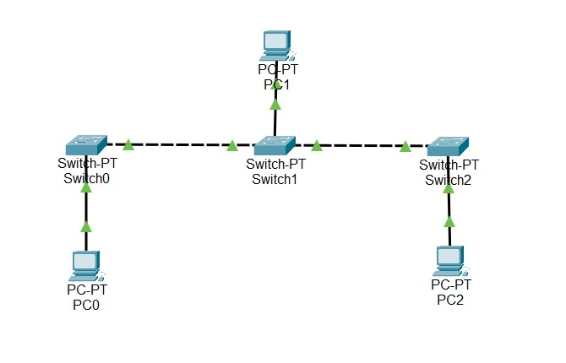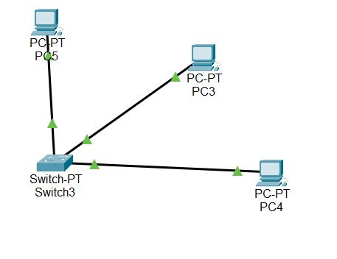

**STEP 1 :**

Drag the required switches and PCs, made the connections using Copper Straight through cables and Copper Crossover Cables.

Copper Straight through cables are used to connect different devices and Copper Crossover cables are used to connect similar devices.

**STEP 2:**

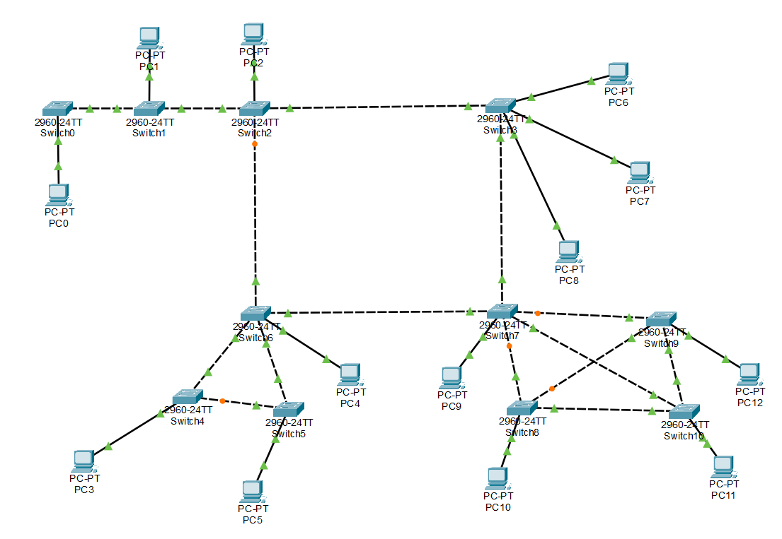

Made the connections accordingly, and connected the bus, star, ring and mesh connections.

**STEP 3:**

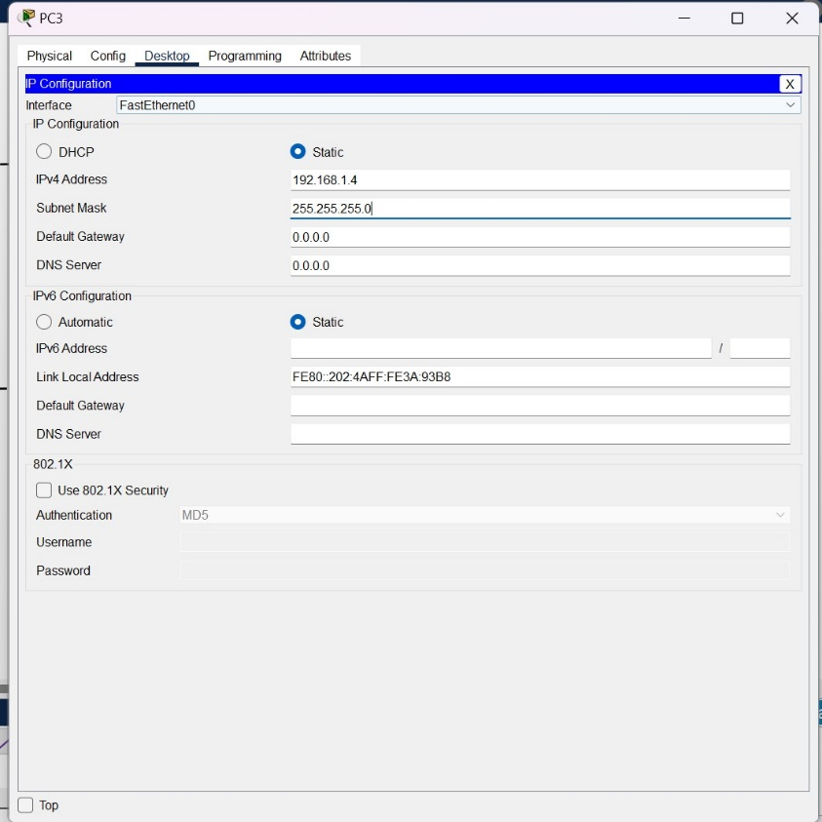

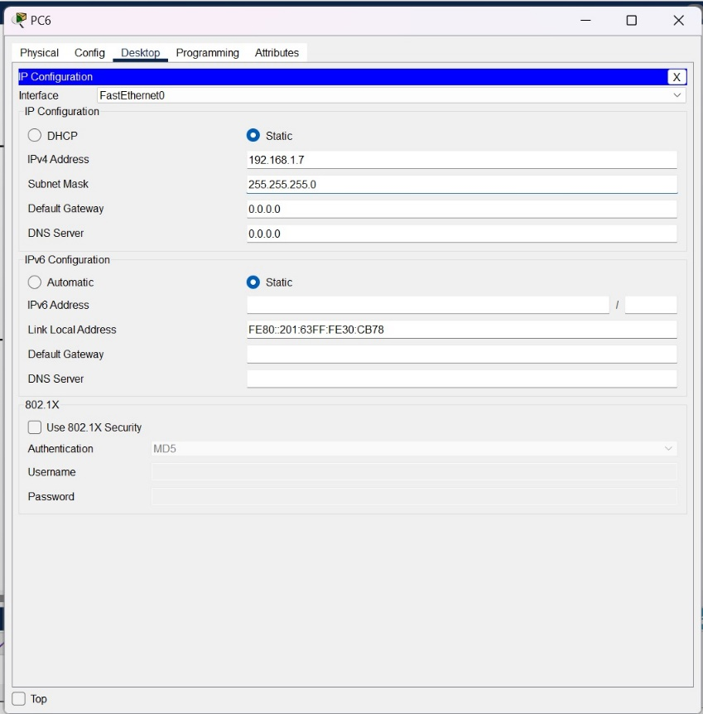

**STEP 4:** Pinging PC6 from PC0

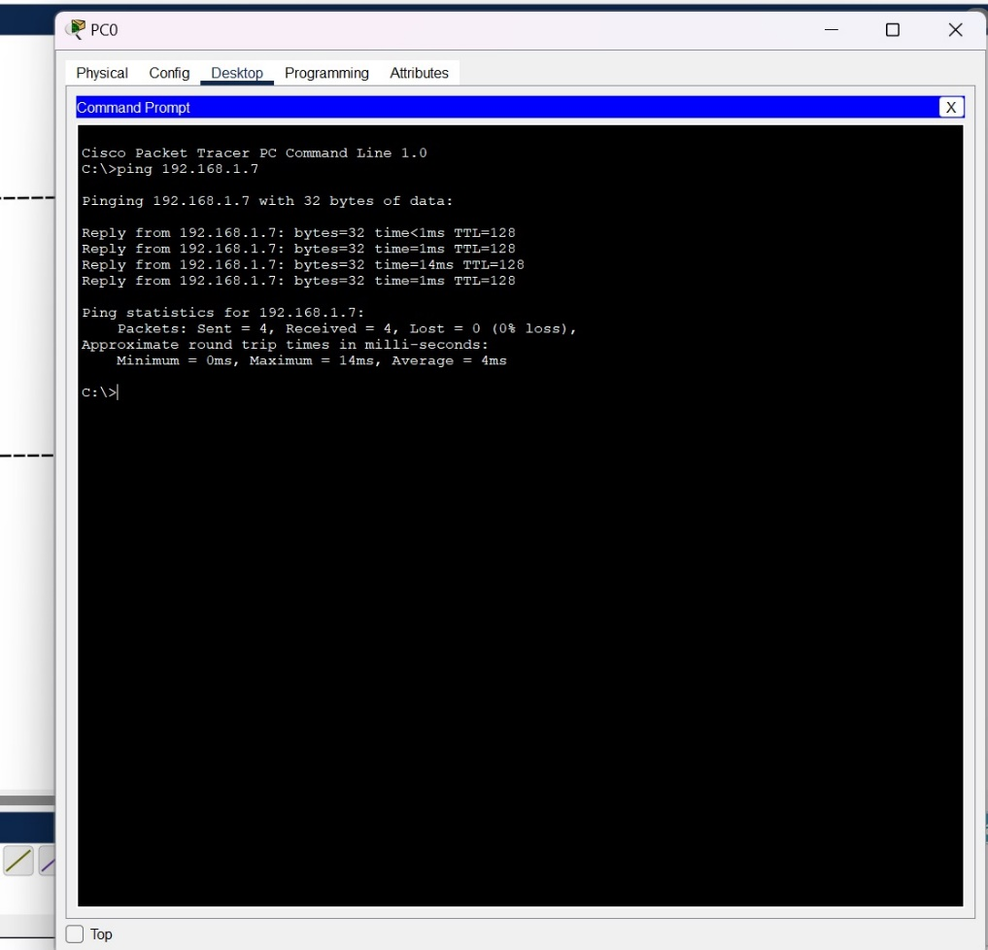

Pinging PC1 from PC0:

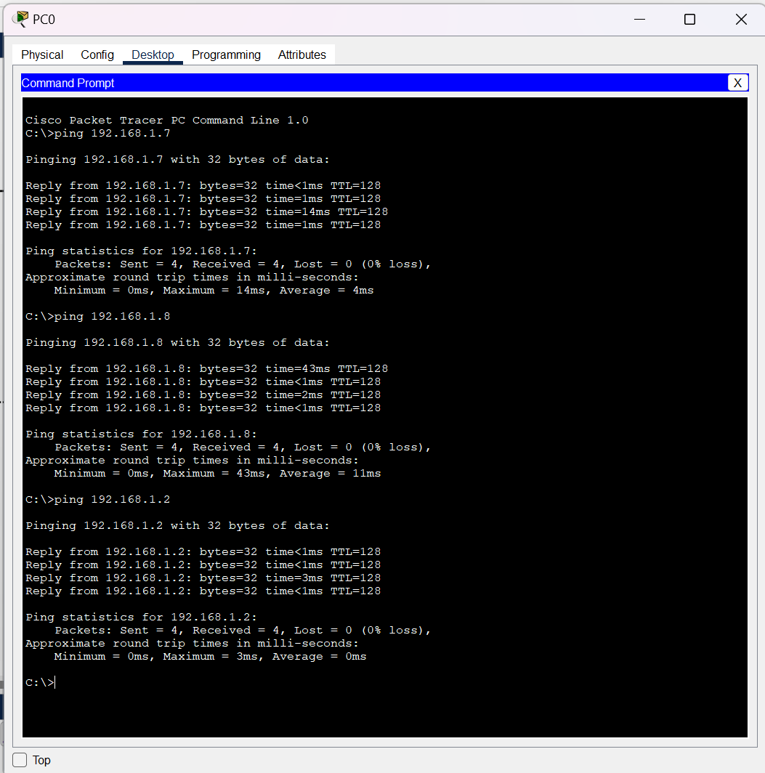

Pinging PC2 to PC0:

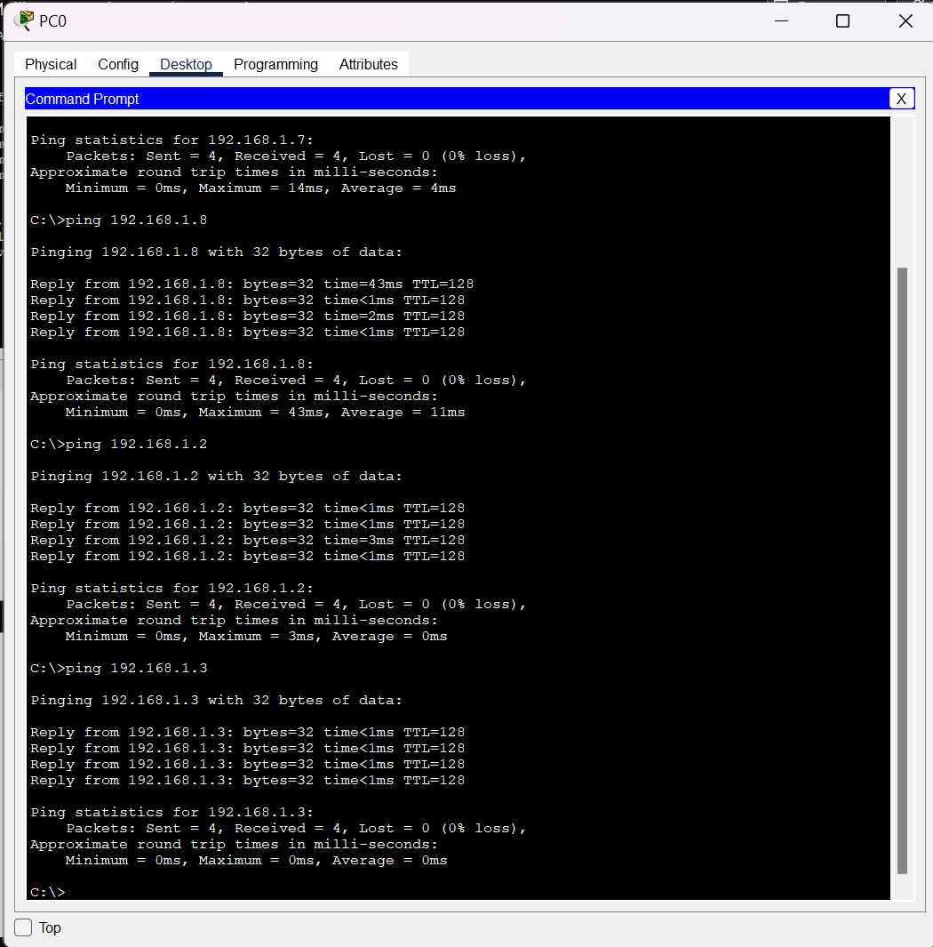

Pinging PC3 from PC0:

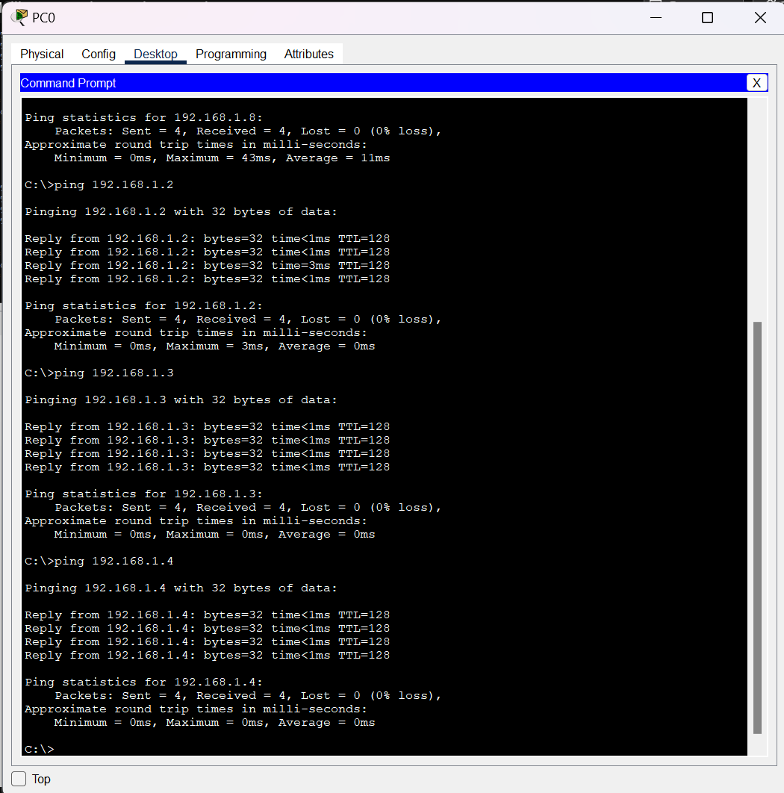

Pinging PC4 from PC0:

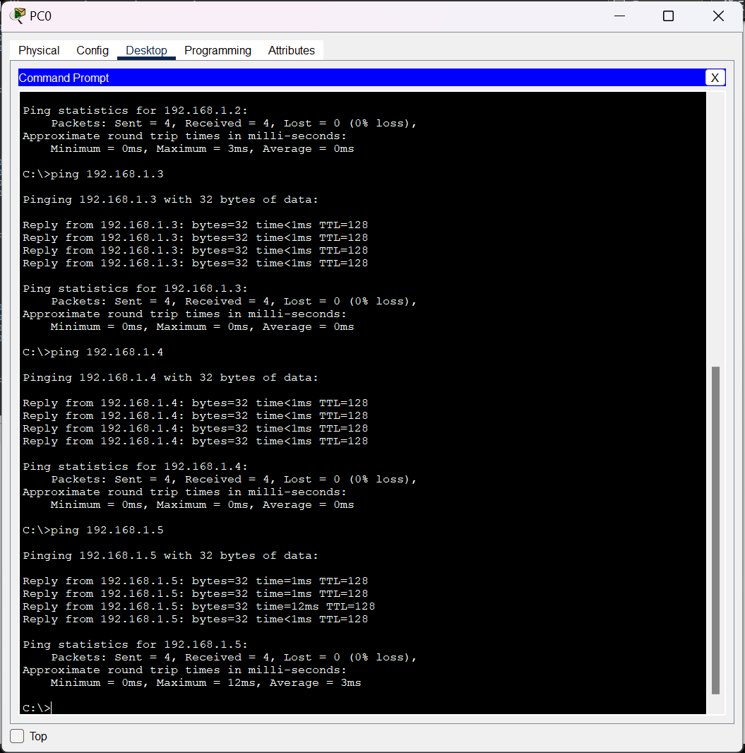

Pinging PC5 from PC0:

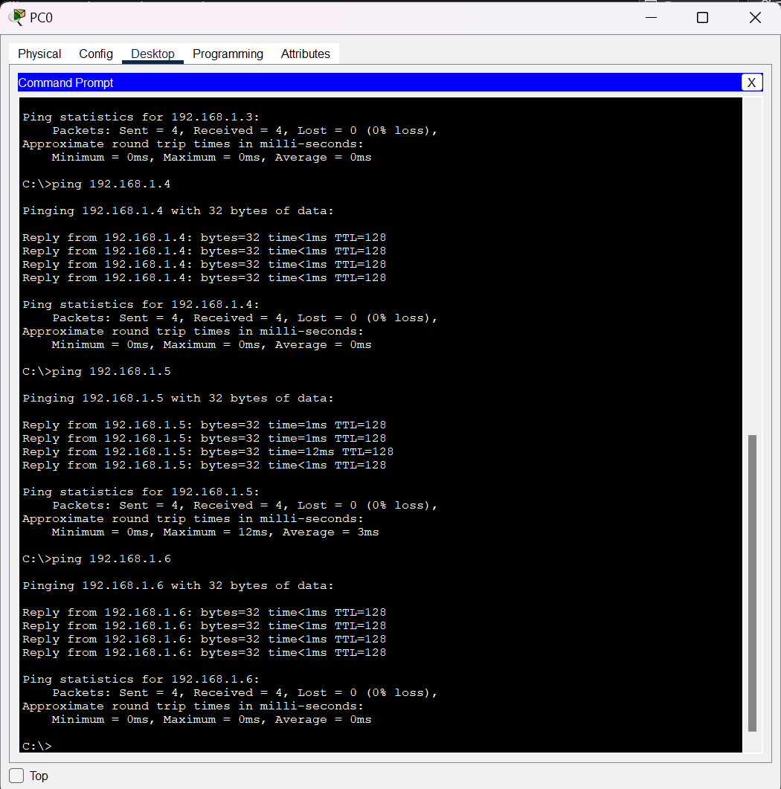

Pinging PC6 from PC0:

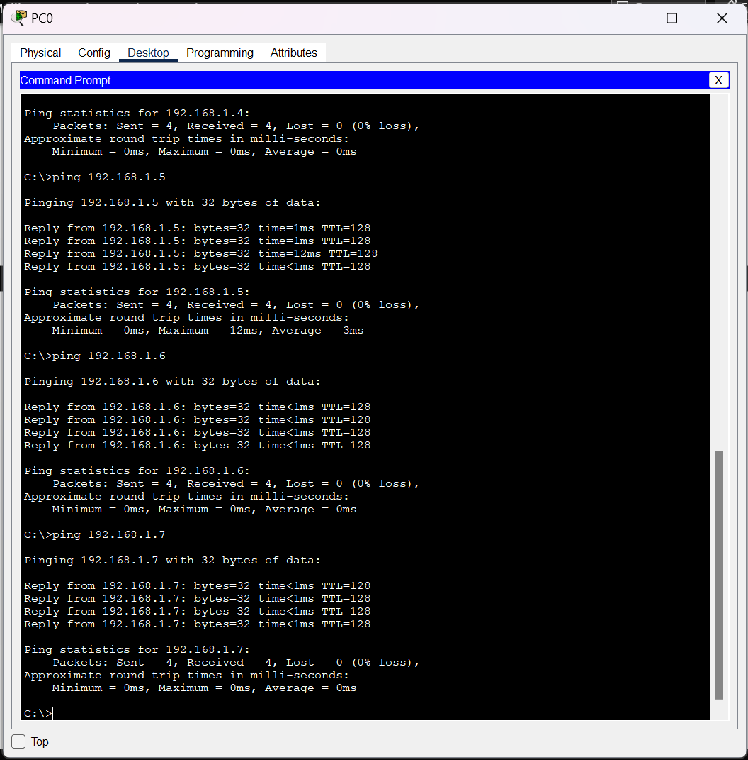

Pinging PC7 from PC0:

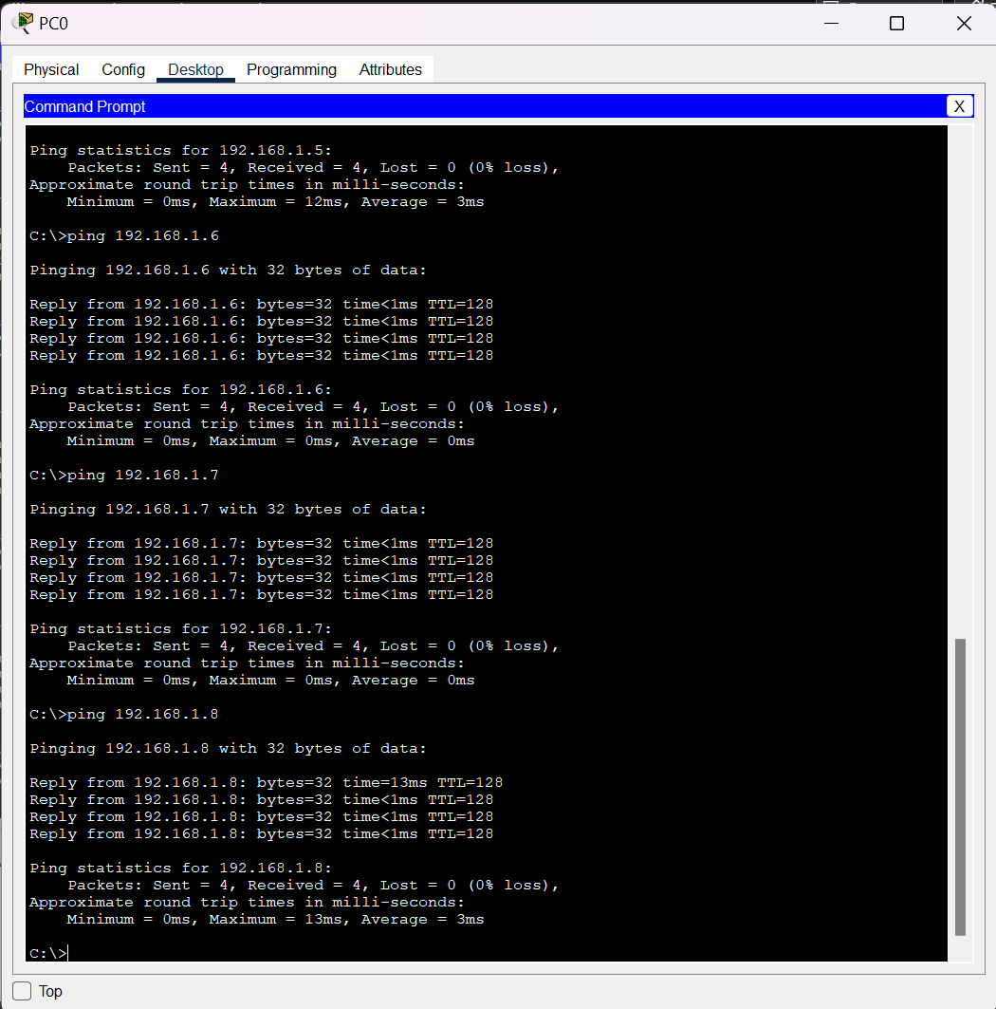

Pinging PC8 from PC0:

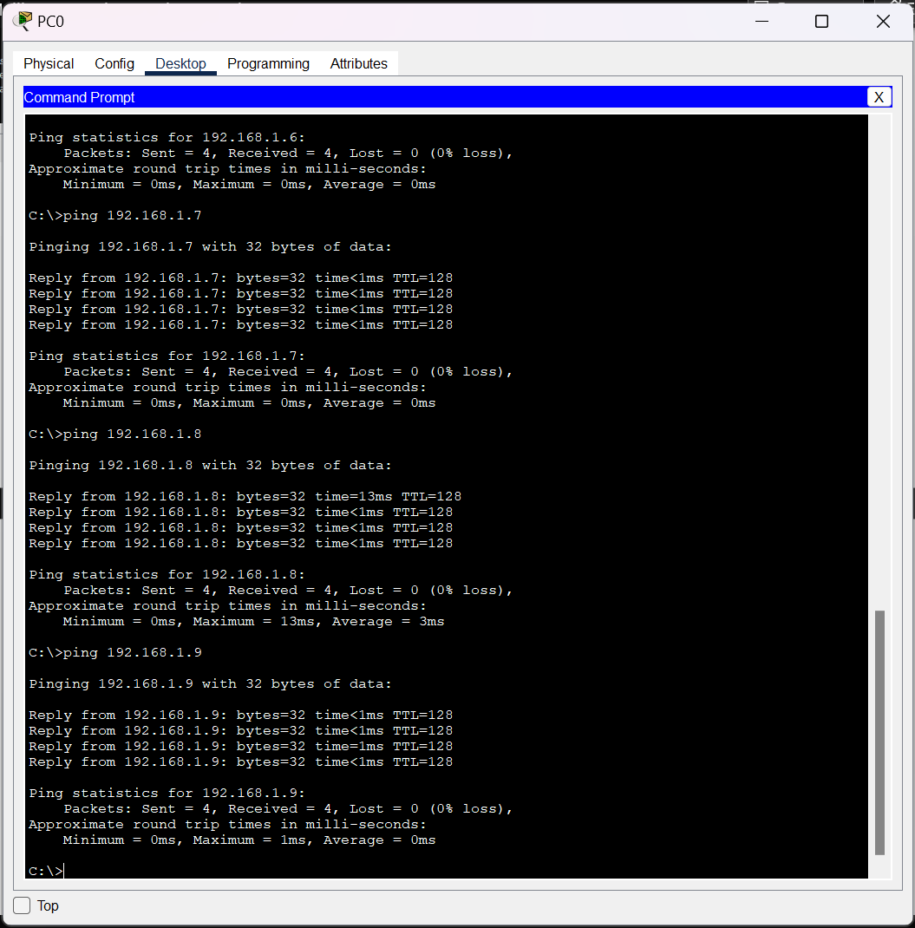

Pinging PC9 from PC0:

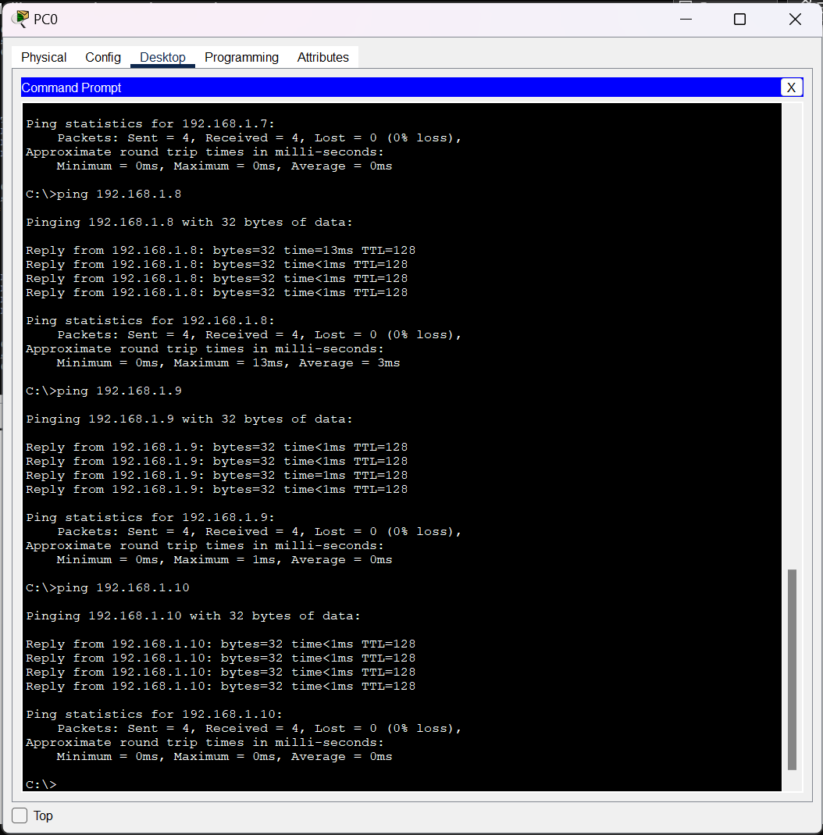

Pinging PC10 from PC0:

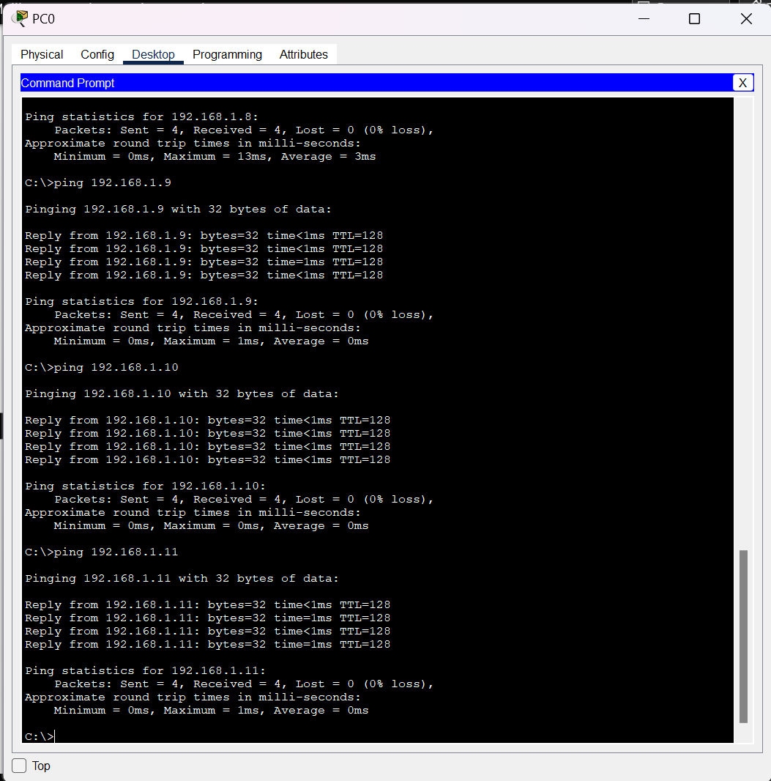

Pinging PC11 from PC0:

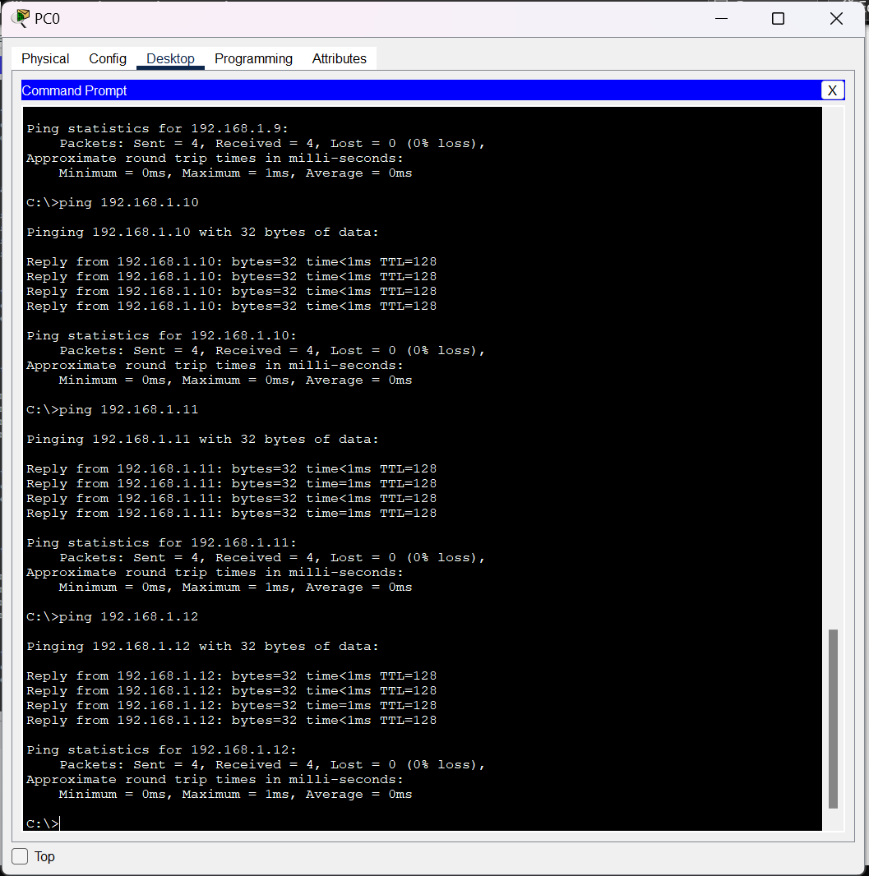

Pinging PC12 from PC0:

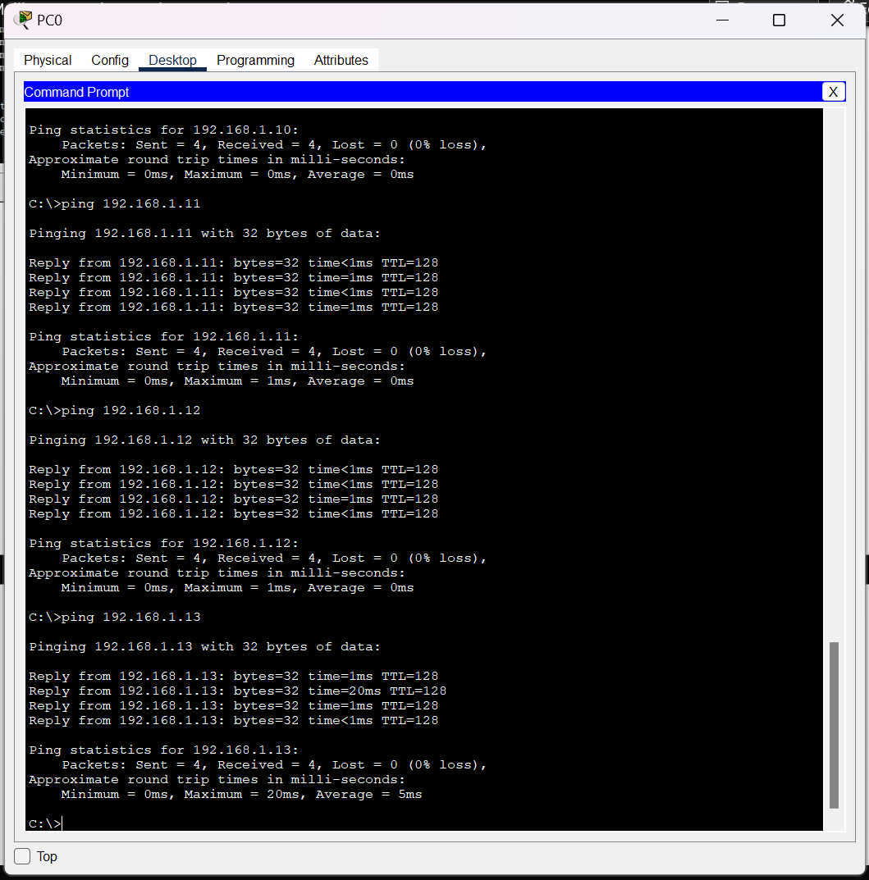

**SIMULATION:**

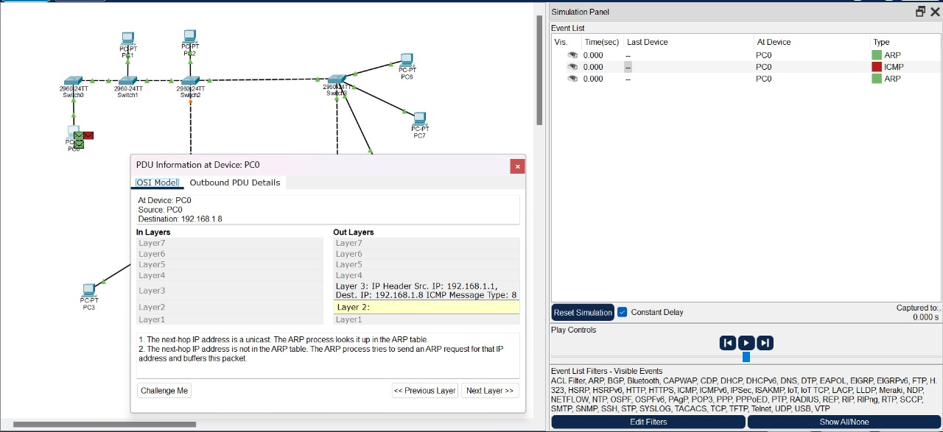

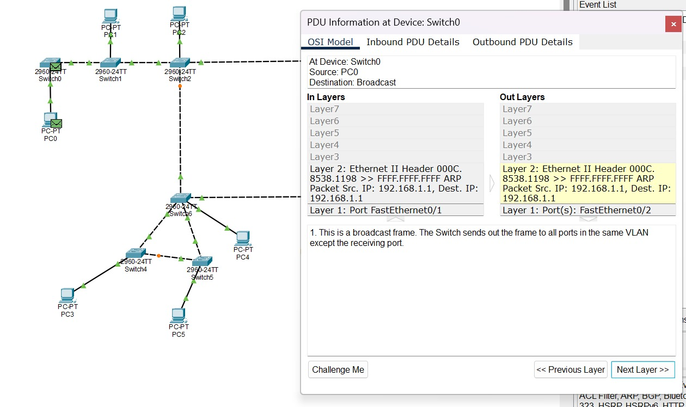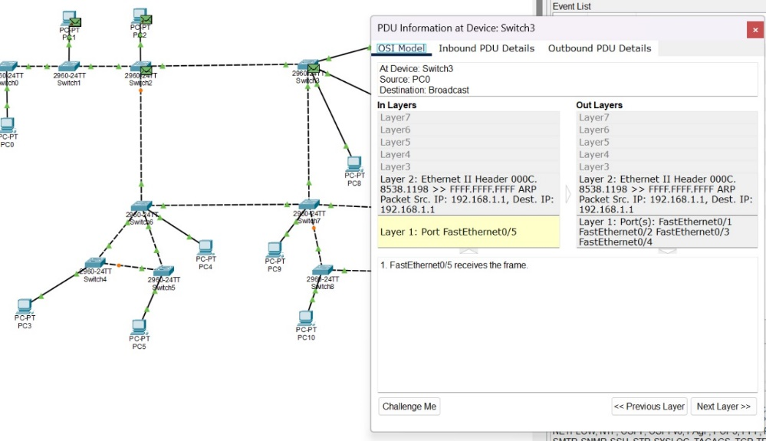

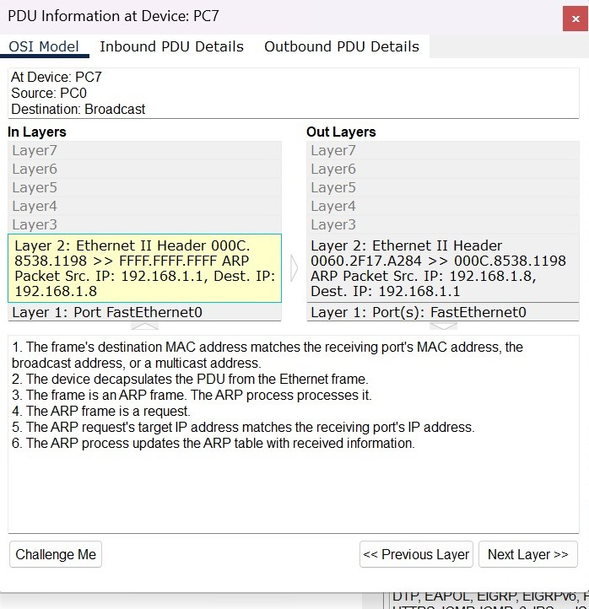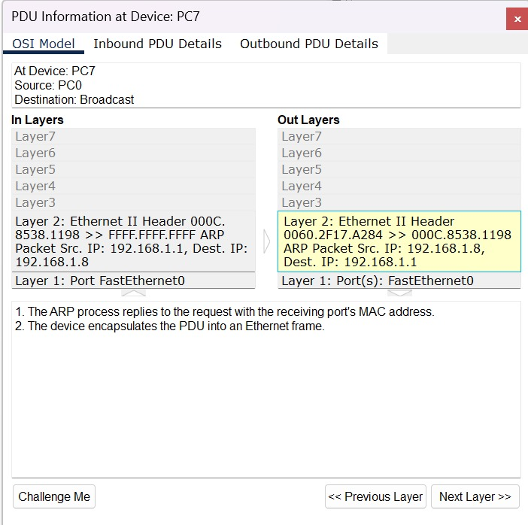

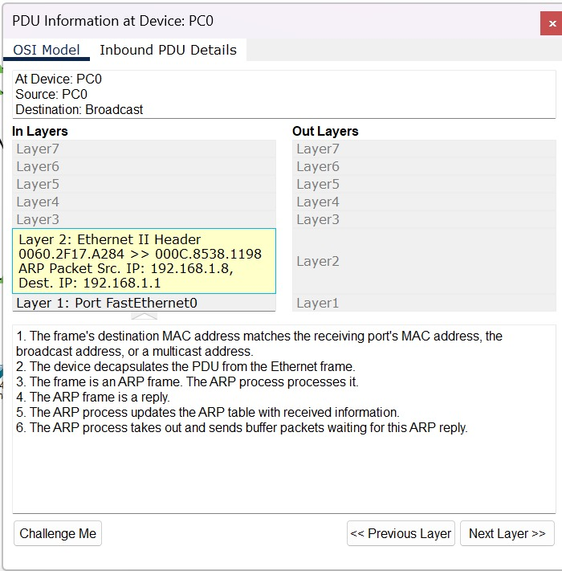

ARP request is sent from PC0 as a broadcast, when PC6 receive ARP request and the destination IP match with that, PC6 sends out a ARP reply with it’s MAC address as a unicast to PC0.